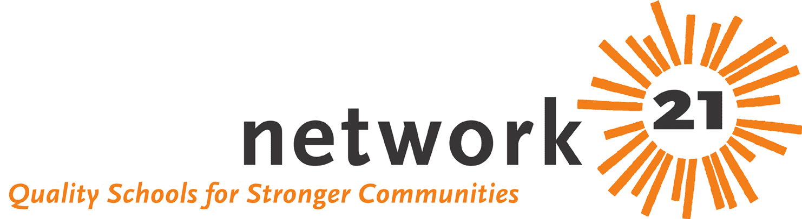 Toolkit for Local Action

[insert date]

Dear Legislator:

I’ve heard alarming things about education in Illinois and I’m worried.

Eighty percent of school districts are now deficit spending. Districts throughout the state are laying off teachers. More than 400,000 public school students do not meet Illinois Learning Standards. Not all districts have the resources to provide an adequate education. Illinois relies too heavily on local districts to fund schools — we’re 48th out of the 50 states, in fact, in the amount the state contributes to education. That leaves property taxes as the revenue source to fund local schools.

According to the Education Funding Advisory Board and research conducted by the Network 21: Quality Schools for Stronger Communities coalition, Illinois must increase the per-student spending foundation level by more than $1,000 to $5,665 annually to provide adequate resources. The federal No Child Left Behind Act requires that by 2014, 100 percent of public school students meet Illinois Learning Standards – and we must make progress each year to meet this stringent goal. The students who are being shortchanged today are being cut off from contributing to our state’s future.

A number of funding and quality reforms are needed to improve our schools. I urge you to support HB 3541, which would raise the foundation level to $5,665 (phased in over three years and corrected for inflation) and improve the poverty grant program.

I also ask you to support continuing the state's school capital and construction program (SB 634), improving the state's assessment system so that it serves as a more effective tool in student learning (HB 2352), expanding early childhood education opportunities and improving teacher mentoring and induction programs.

Thank you for your attention.

Sincerely,

